INTRODUCTION:
Torsional responses of building structures could be induced by structural eccentricities and by varying multiple ground excitations. Generally torsion occurs in structures which are unsymmetrical.
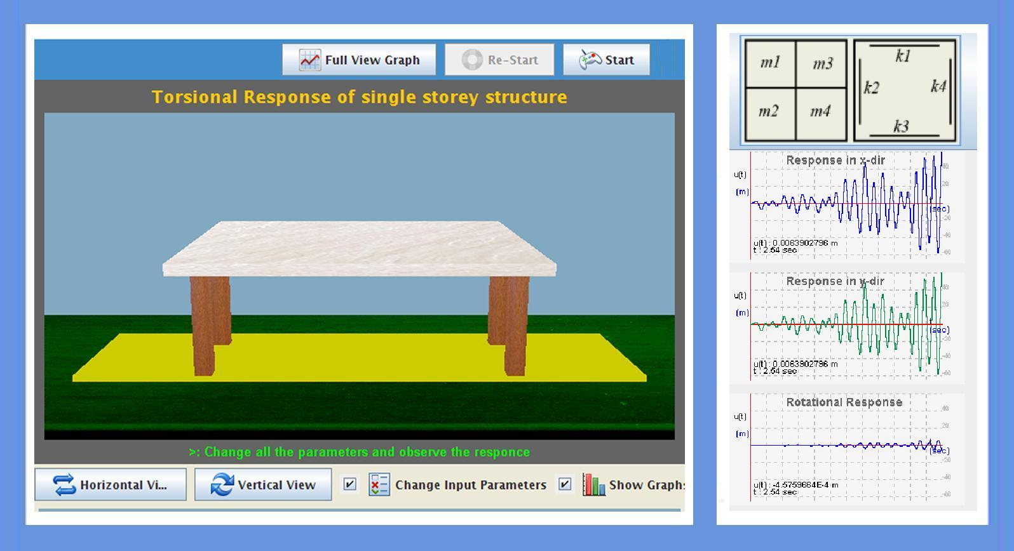

THEORY:

Equation of motion excluding damping forces
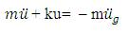
For two way unsymmetrical system:
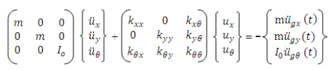

Where

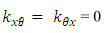
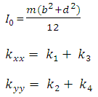
If the system is symmetric about x-axis then
If the system is symmetric about y-axis then

OBJECTIVE:

To find out the responses of 3 DOF's (2 translations and 1 rotation) of a single storey structure especially torsional response along with translations.

MANUAL:
Here mass of slab is given as 4 parts and stiffness as 4 parts in both directions. Experiment starts with default values of masses and stiffnesses. Observe the SDOF response in 3 directions (2 translations and 1 rotation/torsion)
Observation 1:
Here in this stage, user can change mass of slab corresponding to default value by keeping all other as default values. Observe the difference in 3 directions response.
Observation 2:
Here in this stage, user can change stiffness corresponding to default value by keeping all other as default values. Observe the difference in 3 directions response
Observation 3:
In this stage, user can change all the parameters including damping ratio and earthquake data and observe the variations/difference in all directions responses of structure.

PART - 2
ANIMATION STEPS
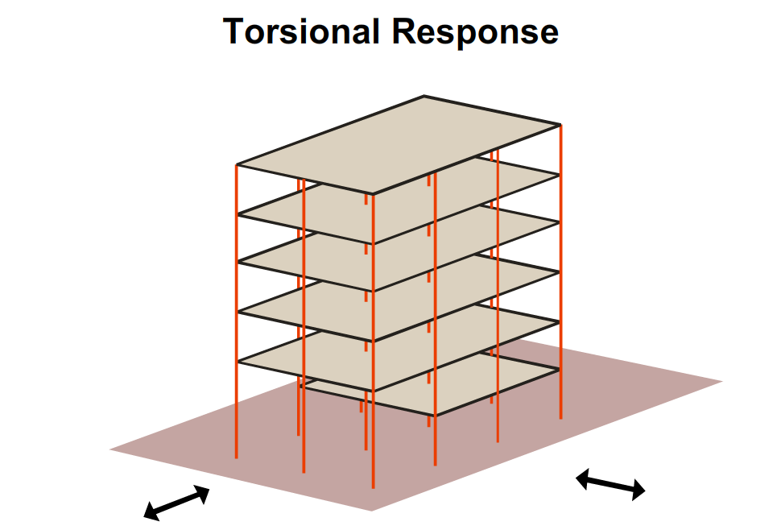

PART – 3
VIRTUAL LAB FRAME
